PURPOSE:
This guide is intended as a tool to support conversations around best practices among educators so that all students, including students with disabilities, are served within a comprehensive continuum of supports that helps them reach their full potential in all areas of their education. While MTSS is not a special education initiative, a well-implemented MTSS framework supports all students, including students with disabilities.

INCLUSIVE PRACTICES OF MTSS:
By definition, MTSS is a system of multiple tiers designed to meet the needs of all students by

- Thoughtfully assessing students to provide academic and behavioral information necessary for decision making around instruction and support needs,
- Collaborating regularly to improve adult practices to better understand and plan for student needs,
- Using resources effectively,
- Understanding that all tiers are available to students of all populations, including special education, and
- Relying on progress monitoring data to improve instructional effectiveness in every corner of your system.

MTSS WITHIN GENERAL EDUCATION & SPECIAL EDUCATION✦:

- MTSS offers a replacement to the “wait-to-fail” model
  - MTSS relies on consistent practices of assessing early, providing support quickly and progress monitoring to help differentiate between students who’ve experienced gaps in their education and those who truly need special education services.
  - In Illinois, MTSS is found in the Illinois Administrative Code detailing expectations of its use as part of the evaluation process for students suspected of having a specific learning disability.^{2, 3}
  - If special education needs are identified, a record of instructional problem solving and progress monitoring of interventions can help support the determination.
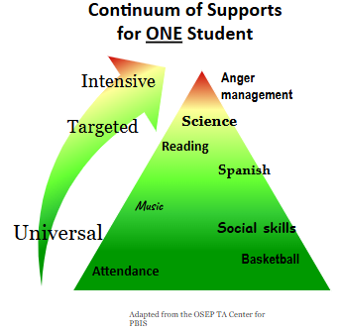
  - MTSS documentation will also inform the development of impactful and effective IEPs.
  - Special education law requires students to be served in the least restrictive environment. Many students with IEPs, particularly those with high incidence disabilities, spend most or all of their day in general education settings which is where a variety of MTSS supports are available to all, including students with disabilities.¹

- MTSS progress monitoring can help determine if/when a student should be exiting from
an IEP
- MTSS can help students served through IEPs move from higher levels of intensive supports into Tier 2 or Tier 1 instruction/support

OTHER BENEFITS:
Key Elements of MTSS Potential Benefits for Special Education
- Collaborative Teams - Promotes shared responsibility and expertise
- Data-Informed Decision Making - Ensures targeted and individualized support
- Consistent Progress Monitoring - Promotes timely adjustment to instruction/interventions
- Shared Professional Learning - Enhances all educators’ knowledge and skills
- Family & Community Engagement - Builds a strong support system for students

GUIDING QUESTIONS:
- Are both special educators and general educators represented on leadership and implementation teams?
- Are special educators actively and regularly included in professional learning options and sessions for all staff as well as those designed for their specialized roles?
- Are both special educators and general educators actively and regularly involved in collaboration with grade level or content area teams?
- Do school processes and planning provide time for general and special educators to be together on a regular basis to review student assessment results? And then to co-plan/ co-design instruction based on that data?
- What is currently in place, or can be put in place, to plan for improvements in these areas?

REFERENCES:
¹Fabiano, G. A. (2022). The connection between MTSS and special education: Why it matters.
Renaissance See Every Student 2022 Blog
² ISBE SPED_RtI_Framework Documents

³ ILGA JCAR Admin Code
Novak., K., & Rodriguez, K. (2023). In support of students: A leader’s guide to equitable MTSS.
Novak., K., & Rodriguez., K. (nd). Massachusetts Department of Elementary & Secondary Education
MTSS RESOURCE: MTSS & Special Education. MTSS & Special Education Massachusetts.
✦This guide, in its whole or in parts, is not intended to substitute for your compliance in following requirements of federal and state special education policies and procedures for programs, eligibility, service provision or student rights.

